**Course: HTTP5302 – Trends in Web Development**

**Title: Assignment 2 Part 2**

**Section: ONA**

**Instructor: Lee Situ**

**Submitted by: Muhammad A Nadeem (N01188700)**

**My Hero List**

By: **Muhammad A Nadeem**

**Introduction**

‘My-Hero-List’ is a RESTful web service that contains information about my favourite heroes (still active or no longer active in their fields) of our global system.

Just tap into My-Hero-List to learn about the heroes around us in the field of politics, sports, and philanthropy. Great for quick and up-to-date information about few famous personalities!

‘My Hero List’ will return information on few of my heroes in my list per API request. Results are in JSON format.

**Instructions**

Endpoint: [http://myheroapi-nadeem.azurewebsites.net/api/Getheroes](http://myheroapi-nadeem.azurewebsites.net/api/Getheroes%20)

Using My-Hero-List requires knowing how to interpret query strings, use query string variables, and JSON formatting.

Authorization is not required to use My-Hero-List as it is considered an open source. So no API key is needed.

Supply the query string variable and value to the endpoint for each request in a format like <http://myheroapi-nadeem.azurewebsites.net/api/Gethero?id=4>

My-Hero-List will return the HTTP status code of 404 (*if Azure service is not available*) back to your application. My-Hero-List is in production so developers are welcome to use it. This is subject to change upon subsequent releases of My-Hero-List.

There are two methods of querying the contents of My-hero-List expression. You may either search for hero by id or retrieve all heroes. Only one method may be used. If heroes are searched by id, My-Hero-List will retrieve results only by id associated with the hero.

To retrieve a hero’s information by id, supply the 'id' query string value with an integer. This will return a JSON object of a hero's details. If integer supplied to 'id' does not correspond to an id[1], the returned JSON object will be empty with a message “*No webpage was found for the web address:****http://myheroapi-nadeem.azurewebsites.net/api/Gethero?id=11***”

If only the query string variable is supplied without an id, then all heroes from My-Hero-List will be returned in a JSON array object. <http://myheroapi-nadeem.azurewebsites.net/api/Getheroes>

**Example**

Here is an example of using My-Hero-List in a javascript AJAX request:

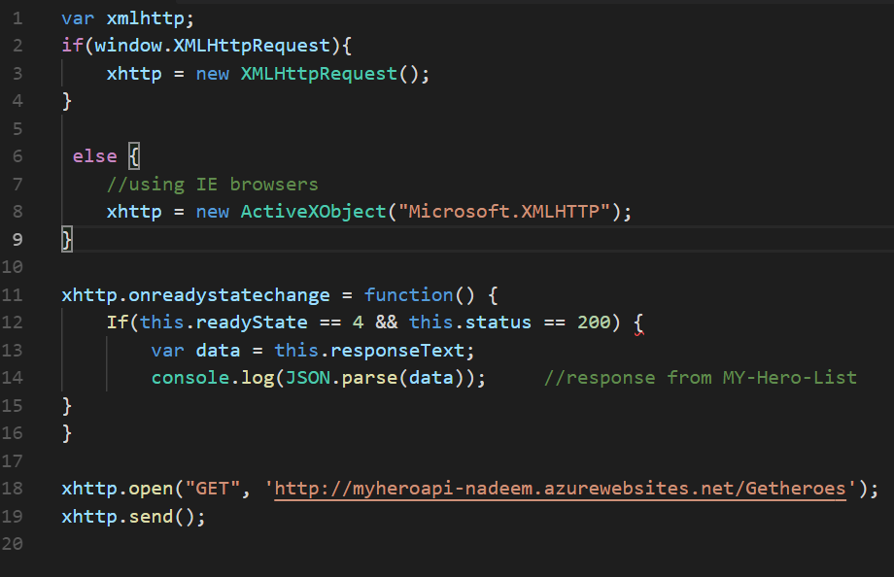

**Contact Questions/Comments/Complaints**

Any and all inquiries should be emailed to nadeem133@hotmail.com.

**Terms of Use**

Developers may use My-Hero-List so long as they adhere to the contents of this Terms of Use. My-Hero-List may be used for education purposes only and must reference the following URL as a code comment: <https://github.com/Nadeem133/myheroAPI>

1. Heroes database list doesn’t contain any 11th id